R. Gonzalez Management Inc. (RGM)
Student Financial Aid Services Phone No. (323) 730-8700
3560 S. La Cienega Blvd. Suite G Fax No. (323) 730-8701
Los Angeles, CA 90016-4400 Web Page http://www.rgmsms.com
RGM Memo
Date: April 3, 2018
To: School Owners and Financial Aid Personnel,
RE: Reporting Results on CPS for Verification Groups V4 and V5
You can download V4 and V5 results from the RGM system. Please see the steps below

Enter the key number click search then generate. You then check the box next to key number, verify the items to be verified, change the result from P to 1 then click update:

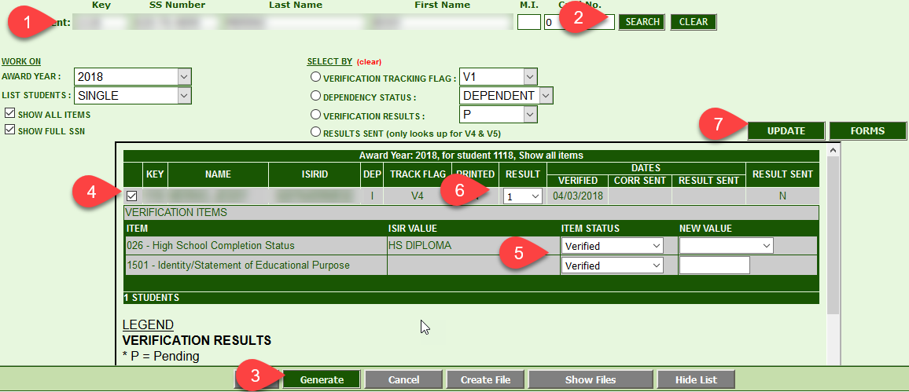

You then click create file, then show files:

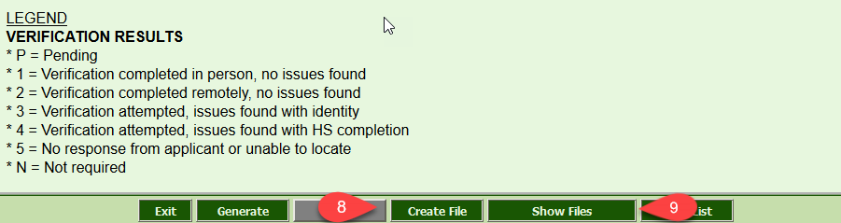

You click on the verification results you will like to download, then click download file:

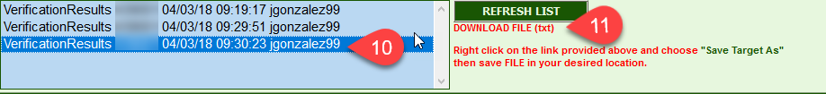

Below are some screenshots on the process for posting the results in CPS:

Go to FAA Access to CPS Online, https://faaaccess.ed.gov , after logging in, Click “Identity Verification Results.”

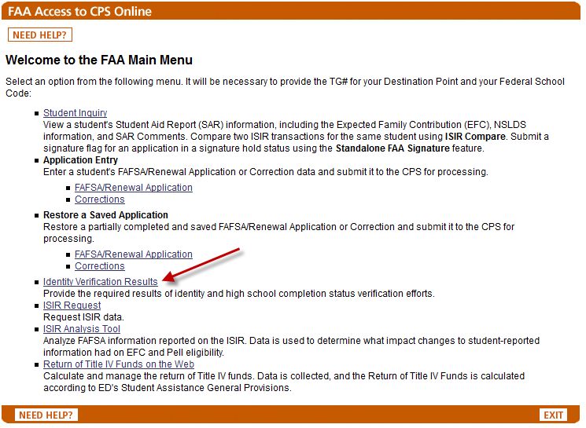

You will need enter the following information:
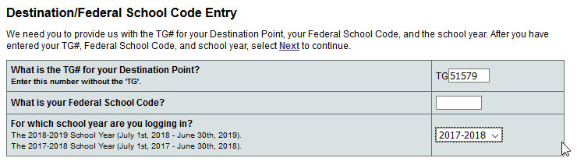

The TG # that you will use is RGM TG#51579. Your Federal School Code can be found in the RGM system in TRX#1003, under the “Financial Aid Settings” Tab, under FPELL ID:

You have two options to upload the information:

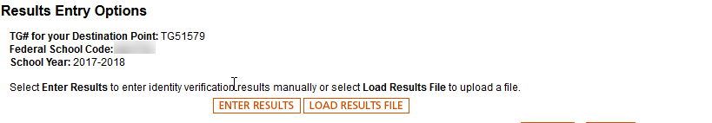

- If you choose to enter the results, you will need to enter the SSN, Name ID (First two characters of the Last Name in the ISIR ID) and the results. After you are done, Click “Results Entry Complete.”

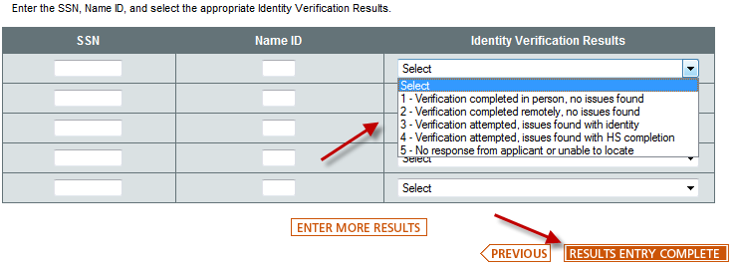

2. You can upload the information using the file that was created in our system to CPS by Clicking “Load Results File.”
3. Browse to the file location (where you’ve downloaded the file from the RGM system, see above on sample on how to download) and insert the file. Once done, click “Upload Results”

In the end you will get the final results you posted, please print for your records and for audit purposes.

